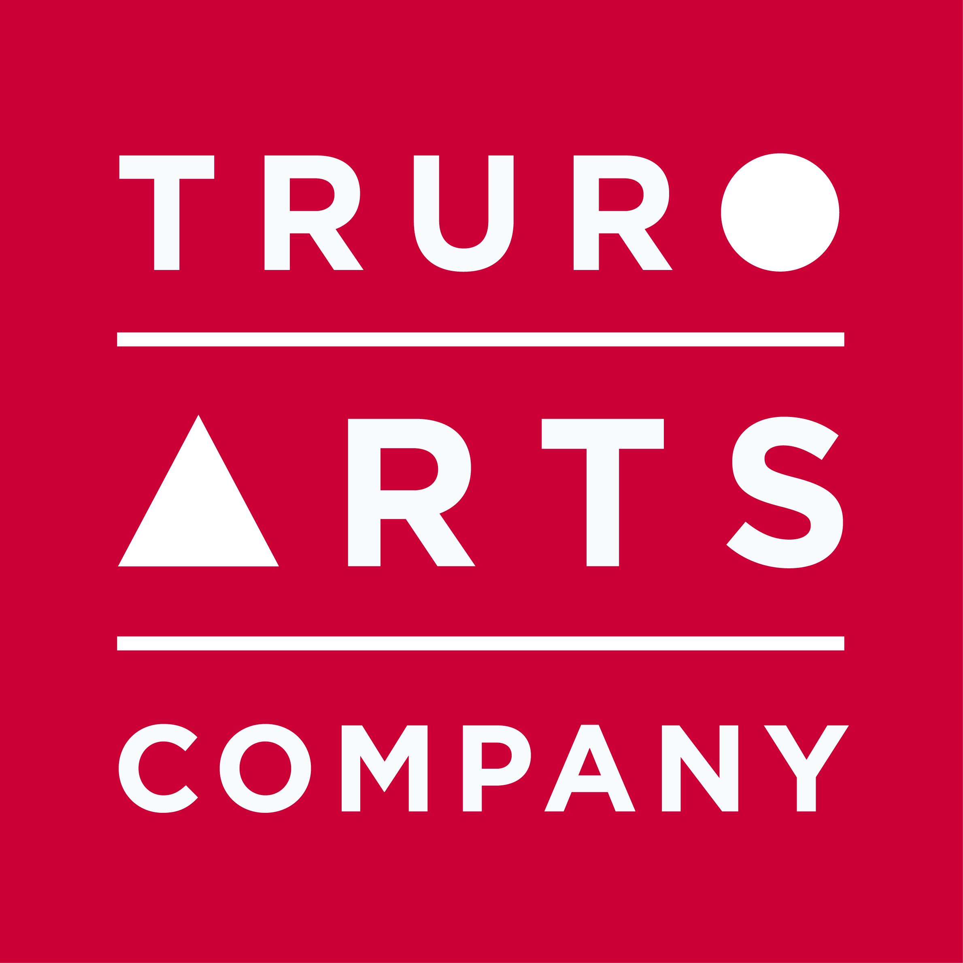

Materials List

Laura Menzies

Cold Wax Medium & Oils

Monday 9th March 2020, 10am – 4pm

- A good selection of oil paints - a variety of transparent and opaque colours is ideal
- Palettes – disposable palette pads are ideal
- Small A4 and A3 primed boards
- Palette knives
- Masking tape
- Rubber roller
- Sheets of newsprint
- Tools to make marks – forks etc
- Strong kitchen roll
- Apron
- Low odour turpentine or similar

Truro Arts will supply the Cold Wax Medium, the Arches oil paper, and disposable gloves required for this workshop.

All materials are available to purchase in the Truro Arts shop and you will receive a 10% discount on all supplies on the day of workshop.

Cancellation policy: Workshops are non-refundable unless we can fill your space.

