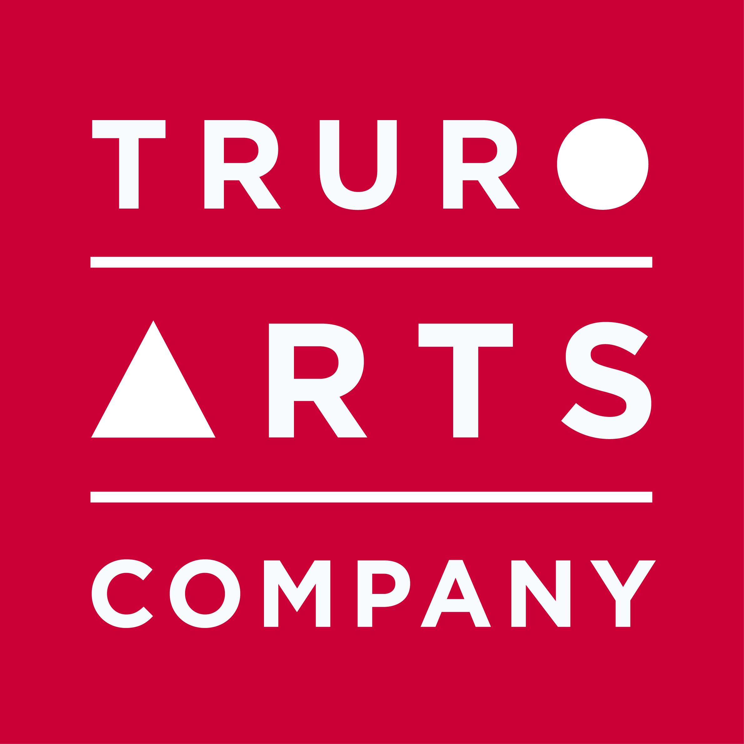

Materials List

Mixed Media with Amanda Hoskin
Monday 28th October, 10am – 4pm.

- Oil/ watercolour/ acrylic paints
- Oil and soft pastels
- Charcoal
- Paper for collage e.g. tissue/ newspaper/ maps anything like that
- Watercolour and acrylic inks
- Brushes/ palette knife
- Board, paper or canvas (up to you)
- Table easel

All are available to purchase in the Truro Arts shop and you will receive
a 10% discount on all supplies on the day of workshop.

Cancellation policy: Workshops are non-refundable unless we can fill your space.

