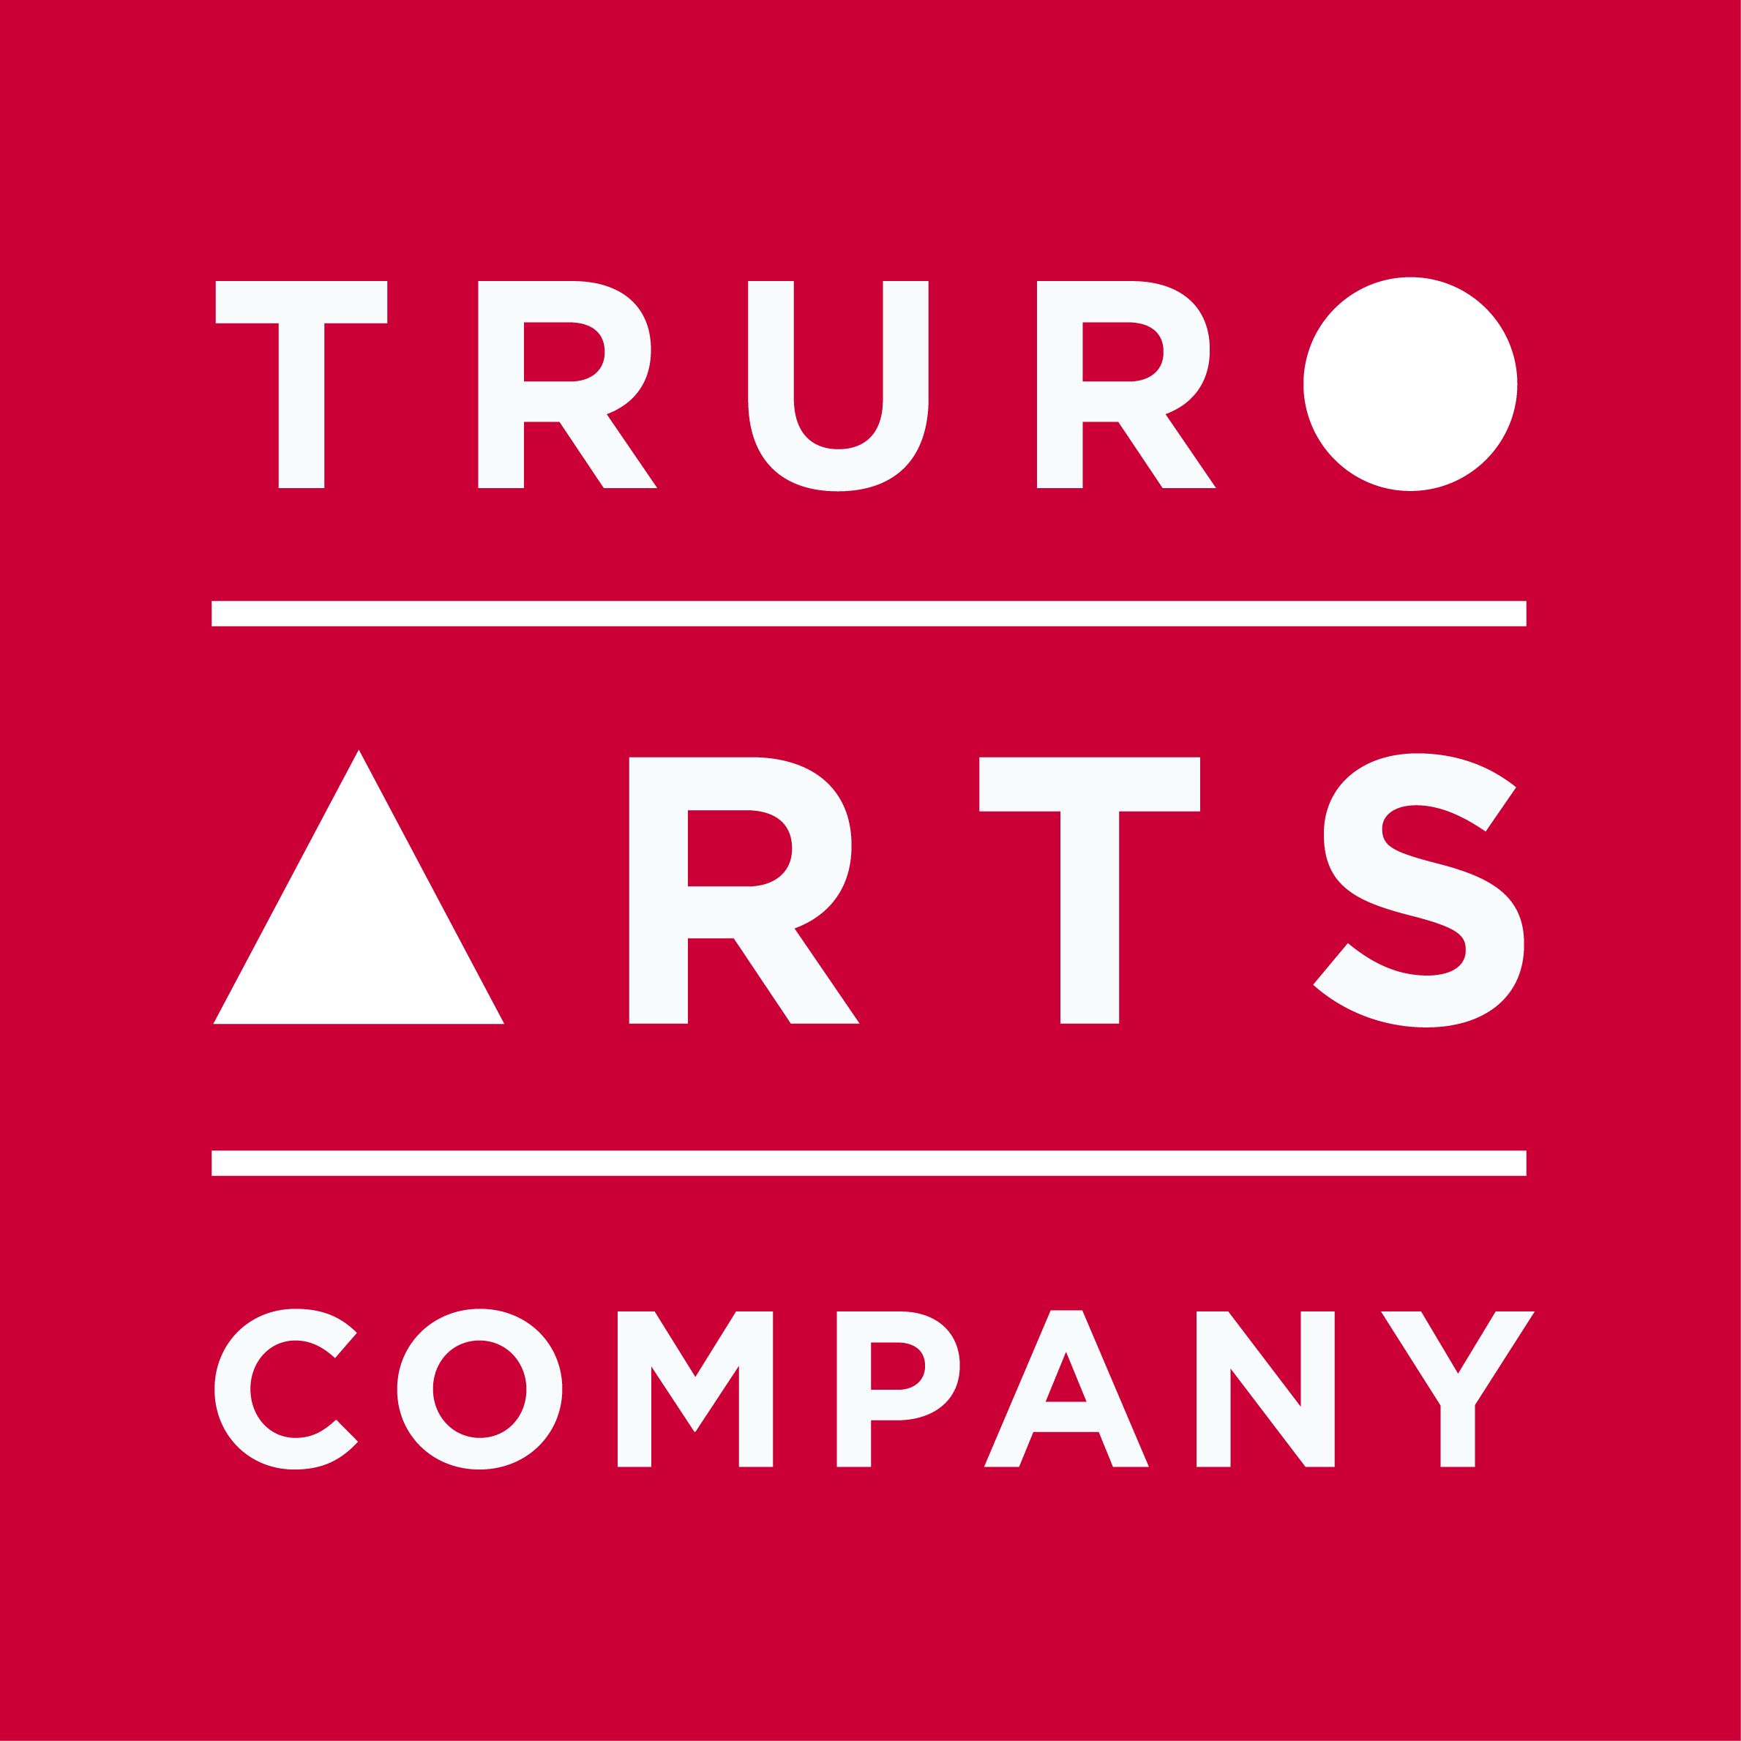

Materials List

Sarah Wimperis

Inspired by Vincent – Landscapes in Acrylics/ Oils

Tuesday 26th May, 2020, 10am - 4pm

- Acrylic (or oil) paints in the following colours:

- Prussian Blue
- Ultramarine
- Emerald Green
- Sap Green
- Cadmium Lemon
- Cadmium Yellow
- Cadmium Red
- Alizarin Crimson
- Vandyke Brown
- Burnt Sienna
- Yellow Ochre
- Titanium White
- Ivory Black

- Kitchen roll, jam jar with a lid
- Brushes to include a Filbert 3, 6, 10 (small, medium and a bit bigger)
- Canvas - 30 x 40 cm
- Palette Knives
- Palette
- Table easel or something to prop canvas up on

All art materials are available to purchase in the Truro Arts shop and you will receive a 10% discount on all supplies on the day of workshop.

Cancellation policy: Workshops are non-refundable unless we can fill your space.

