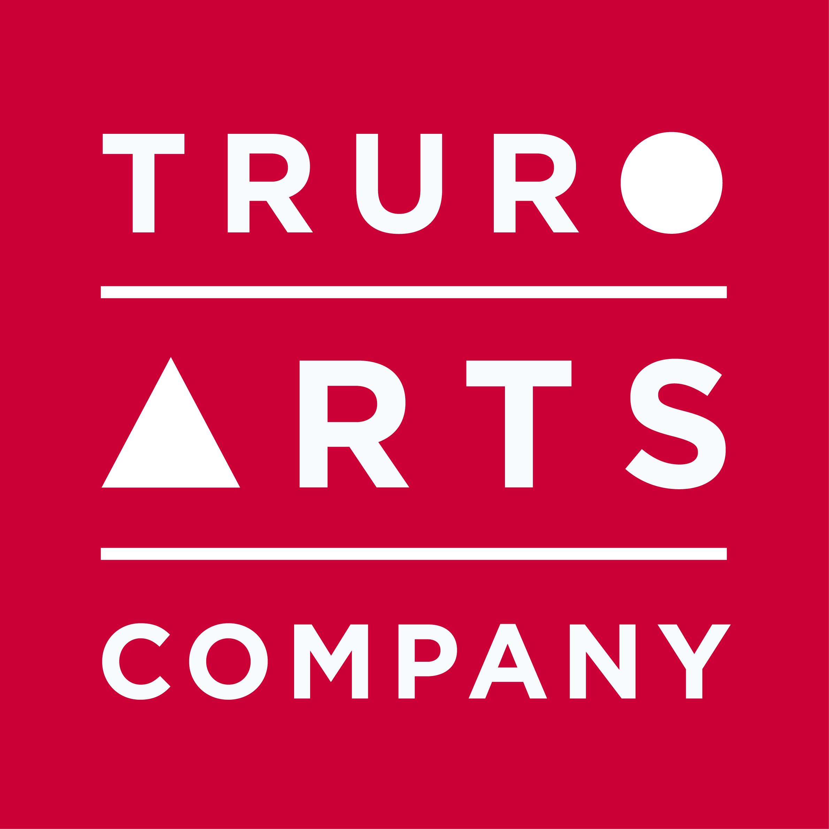

Materials List
Big Sky Basics
in Oils

with Georgina Potter

Sunday 21st May 2020, 10am – 4pm

Oil paints:
- Titanium White (large tube preferably)
- Cadmium Yellow
- Cadmium Lemon Yellow
- Cadmium Red
- Alizarin Crimson
- Cobalt Blue
- French Ultramarine Blue
- Kings Blue Deep
- Phthalo Turquoise
- Raw Sienna
- Lamp Black

Additional colours to bring if possible but not necessary:

- Indian Yellow
- Unbleached Titanium
- Cadmium Orange

- A selection of brushes to include some flat heads (one or two over 1” wide)
- Palette knife
- Painting Medium (such as a 50/50 mix of linseed oil/ odourless thinner or turps)
- Brush cleaner (turps or white spirit) in a pot
- Kitchen roll
- Baby wipes
- Tupperware or similar to store unused paint after session
- 5 x canvas boards roughly 25 x 30cm to be primed with a diluted wash of Burnt Sienna in advance of workshop
- Table easel if weather requires a studio based workshop (Truro Arts have a few spares but please bring if you have access to one); a lightweight tripod easel if weather allows for some plein air painting.
- A palette
- Either a board carrier, or matchsticks/ masking tape to transport artwork

All art materials are available to purchase at a 10% discount in the Truro Arts shop.

Cancellation policy: Workshops are non-refundable unless we can fill your space.

